Lab 3: Database Processing using PL/SQL Programming

Submit all PL/SQL programs and their output to be saved into a text file Programs_Lab3.sql with sql extension.

1. Explicit cursor using %TYPE anchored declaration.

1. **Declare**
2. current_f_last faculty.f_last%TYPE;
3. current_f_first faculty.f_first%TYPE;
4. current_f_fid faculty.f_id%TYPE;
6. **CURSOR** faculty_cursor **IS**
7. **SELECT** f_last, f_first, f_id
8. **FROM** faculty;
9. **BEGIN**
10. **OPEN** faculty_cursor;
11. LOOP
12. **FETCH** faculty_cursor **INTO** current_f_last, current_f_first, current_f_fid;
13. EXIT **WHEN** faculty_cursor%NOTFOUND;
14. dbms_output.put_line('The faculty member: ' ||
15. current_f_last || ' ' || current_f_first || ' ' || current_f_fid);
16. **END** LOOP;
17. **CLOSE** faculty_cursor;
18. **END**;

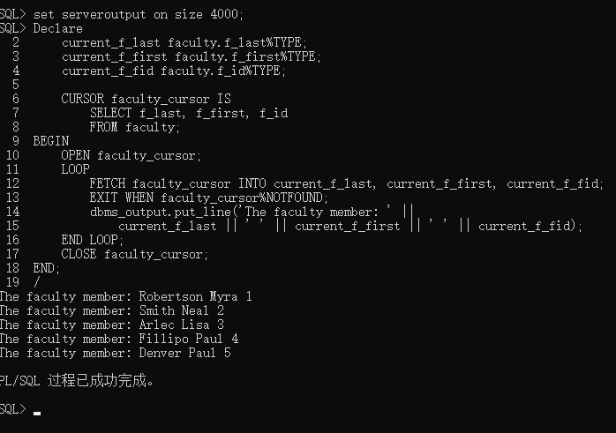

2. Execute the script file registration.sql for creating tables of Registration System.

a) Using explicit cursor, and the reserved word %TYPE variables to display explicit cursor values, Edit PL/SQL program to display all level classes and the description of class using the nested IF/THEN/ELSE as shown in Figure 1.

1. **DECLARE**
2. current_lc_desc levelclass.lc_desc%TYPE;
3. current_lc_min levelclass.lc_min%TYPE;
4. current_lc_max levelclass.lc_max%TYPE;
5. **CURSOR** lc_cursor **IS**
6. **SELECT** lc_desc, lc_min, lc_max
7. **FROM** levelclass;
8. **BEGIN**
9. **OPEN** lc_cursor;
10. LOOP
11. **FETCH** lc_cursor **INTO** current_lc_desc, current_lc_min, current_lc_max;
12. EXIT **WHEN** lc_cursor%NOTFOUND;
13. IF current_lc_max <= 12 **THEN**
14. dbms_output.put_line('LC Type 1, Desc of Class: ' ||
15. 'Small Class, Need to upgrade this class building');
16. ELSIF current_lc_max <= 30 AND current_lc_min > 12 **THEN**
17. dbms_output.put_line('LC Type 2, Desc of Class: ' ||
18. 'Medium Class, Need to Renovate this class building');
19. ELSIF current_lc_max <= 90 AND current_lc_min > 30 **THEN**
20. dbms_output.put_line('LC Type 3, Desc of Class: ' ||
21. 'Large Class, No Renovation for this class building');
22. **ELSE**
23. dbms_output.put_line('LC Type 4, Desc of Class: ' ||
24. 'Extra Large Class, Need to equip this class building with new speakers');
25. **END** IF;
26. **END** LOOP;
27. **CLOSE** lc_cursor;
28. **END**;

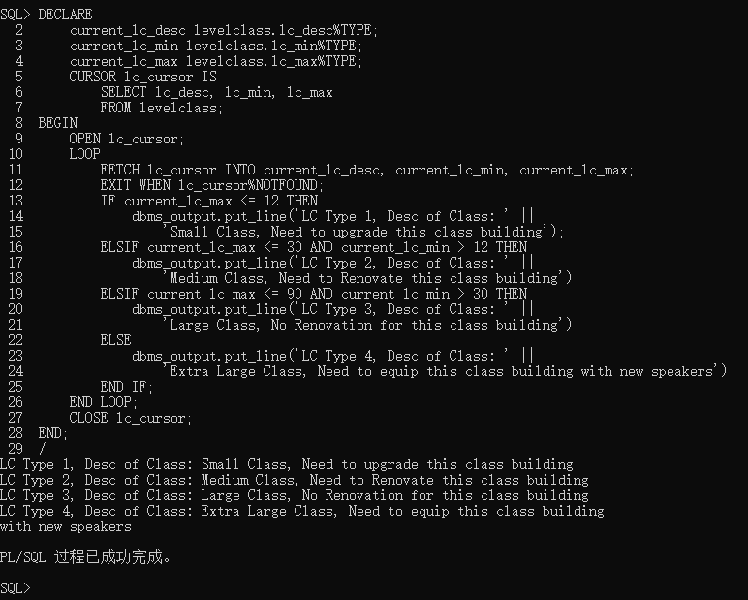

b) Using **Explicit Cursor**, Edit PL/SQL program to display all students’ names within **student** table along with the first name and last name of their respective supervisor to befetched from **faculty** table as shown in Figure 2. Use **%ROWTYPE** variable to displayexplicit cursor values.

Solution I

1. **DECLARE**
2. current_s_last student.s_last%TYPE;
3. current_s_first student.s_first%TYPE;
4. current_s_class student.s_class%TYPE;
5. current_f_id student.f_id%TYPE;
7. **CURSOR** s_cursor **IS**
8. **SELECT** s_last, s_first, s_class, f_id
9. **FROM** student;
10. **BEGIN**
11. **OPEN** s_cursor;
12. LOOP
13. **FETCH** s_cursor **INTO** current_s_last, current_s_first,
14. current_s_class, current_f_id;
15. EXIT **WHEN** s_cursor%NOTFOUND;
16. **DECLARE**
17. current_f_last faculty.f_last%TYPE;
18. current_f_first faculty.f_first%TYPE;
20. **CURSOR** f_cursor **IS**
21. **select** f_last, f_first **from** faculty
22. **WHERE** f_id = current_f_id;
23. **BEGIN**
24. **OPEN** f_cursor;
25. **FETCH** f_cursor **INTO** current_f_last, current_f_first;
26. dbms_output.put_line(current_s_last || ' ' || current_s_first
27. || ', who''s S_class is ' || current_s_class
28. || ', Supervisor name: ' || current_f_last || ' ' || current_f_first);
29. **CLOSE** f_cursor;
30. **END**;
31. **END** LOOP;
32. **CLOSE** s_cursor;
33. **END**;

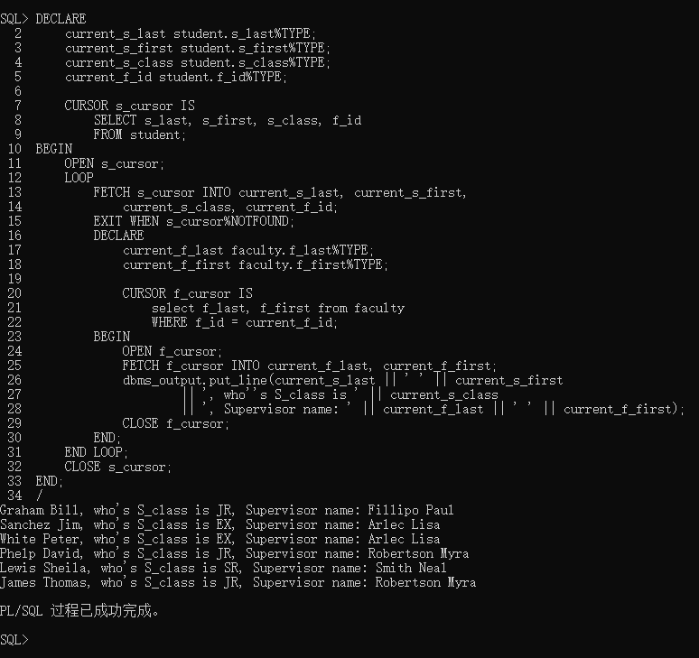

Solution II

1. **DECLARE**
2. s_s_last student.s_last%TYPE;
3. s_s_first student.s_first%TYPE;
4. s_s_class student.s_class%TYPE;
5. f_f_last faculty.f_last%TYPE;
6. f_f_first faculty.f_first%TYPE;
7. **CURSOR** c_cursor **is**
8. **select** s.s_last, s.s_first, s.s_class, f.f_last, f.f_first
9. **from** student s, faculty f
10. **where** s.f_id = f.f_id;
11. **BEGIN**
12. **OPEN** c_cursor;
13. LOOP
14. **FETCH** c_cursor **INTO** s_s_last, s_s_first, s_s_class, f_f_last, f_f_first;
15. EXIT **WHEN** c_cursor%NOTFOUND;
16. dbms_output.put_line(s_s_last || ' ' || s_s_first
17. || ', who''s S_class is ' || s_s_class
18. || ', Supervisor name: ' || f_f_last || ' ' || f_f_first);
19. **END** LOOP;
20. **CLOSE** c_cursor;
21. **END**;

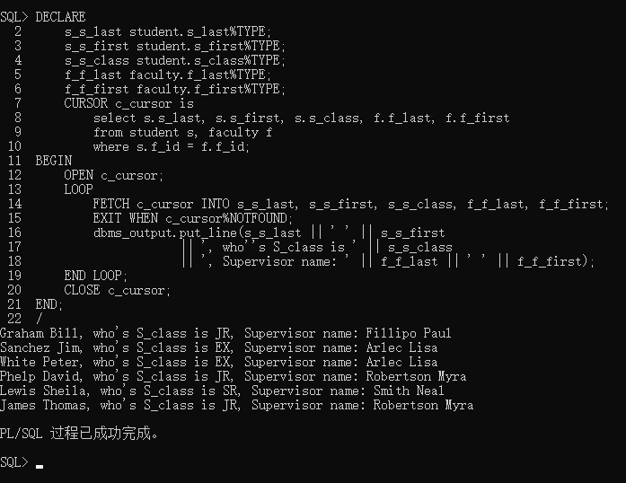

c) Using **explicit cursor**, and the **anchored declaration %TYPE** to display explicit cursorvalues. Edit PL/SQL program to display the total of all available seats (**max_enrl**) of allcourses. Display the output as shown in Figure 3.

1. **DECLARE**
2. c_course_no course.course_no%TYPE;
3. c_course_enrl course.max_enrl%TYPE;
4. c_litstr course.course_no%TYPE;
5. c_code course.course_no%TYPE;
6. seat_number course.max_enrl%TYPE := 0;
7. **CURSOR** c_cursor **IS**
8. **SELECT** course_no, max_enrl
9. **FROM** course;
10. **BEGIN**
11. dbms_output.put_line('The Total of available seat courses is:');
12. **OPEN** c_cursor;
13. LOOP
14. **FETCH** c_cursor **INTO** c_course_no, c_course_enrl;
15. EXIT **WHEN** c_cursor%NOTFOUND;
16. seat_number := seat_number + c_course_enrl;
17. c_litstr := substr(c_course_no, INSTR(c_course_no, ' ') + 1);
18. c_code := substr(c_course_no, INSTR(c_course_no, ' ', -1, 1) + 1);
19. dbms_output.put_line('The Course Inf ' || c_course_no
20. || ', Course Literal String ' || c_litstr
21. || ', Course Code ' || c_code
22. || ' Course Seats ' || c_course_enrl);
23. **END** LOOP;
24. **CLOSE** c_cursor;
25. dbms_output.put_line('The Total of Course Numbering is: ' || seat_number);
27. **END**;

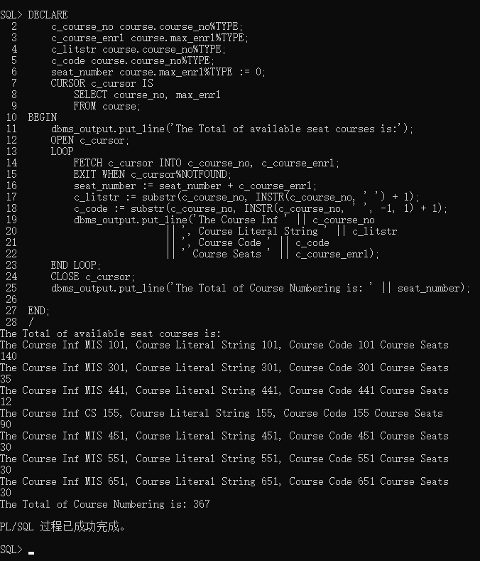

3. Using multiple Explicit Cursors and Joining Tables.a) Using explicit cursor and the anchored declaration %TYPE when declaring variable, edit  
PL/SQL program to display all Faculties, their supervised students and to which  
department they belong. Display the output as shown in Figure 4

1. **DECLARE**
2. current_f_id faculty.f_id%TYPE;
3. current_f_last faculty.f_last%TYPE;
4. current_f_first faculty.f_first%TYPE;
5. current_deptid faculty.deptid%TYPE;
6. **CURSOR** f_cursor **IS**
7. **SELECT** f_id, f_last, f_first, deptid
8. **FROM** faculty;
9. **BEGIN**
10. **OPEN** f_cursor;
11. LOOP
12. **FETCH** f_cursor **INTO** current_f_id, current_f_last,
13. current_f_first, current_deptid;
14. EXIT **WHEN** f_cursor%NOTFOUND;
15. **DECLARE**
16. current_s_last student.s_last%TYPE;
17. current_s_first student.s_first%TYPE;
18. current_s_class student.s_class%TYPE;
19. d_deptname department.deptname%TYPE;
20. d_location department.location%TYPE;
21. s_f_id student.f_id%TYPE;
22. **CURSOR** s_cursor **IS**
23. **SELECT** s_last, s_first, s_class, f_id
24. **FROM** student;
25. **BEGIN**
26. **OPEN** s_cursor;
27. LOOP
28. **FETCH** s_cursor **INTO** current_s_last, current_s_first,
29. current_s_class, s_f_id;
30. EXIT **WHEN** s_cursor%NOTFOUND;
31. IF s_f_id = current_f_id **THEN**
32. dbms_output.put_line('The Faculty Inf: ' || current_f_id || ', '
33. || current_f_last || ' ' || current_f_first);
34. dbms_output.put_line('  Student Name:' || current_s_last
35. || ' ' || current_s_first
36. || ', St Class Type:' || current_s_class);
37. **SELECT** deptname, location
38. **INTO** d_deptname, d_location
39. **FROM** department d
40. **WHERE** d.deptid = current_deptid;
41. dbms_output.put_line('  Dep Info:' || d_deptname
42. || ', ' || d_location);
43. **END** IF;
44. **END** LOOP;
45. **CLOSE** s_cursor;
46. **END**;
47. **END** LOOP;
48. **CLOSE** f_cursor;
49. **END**;

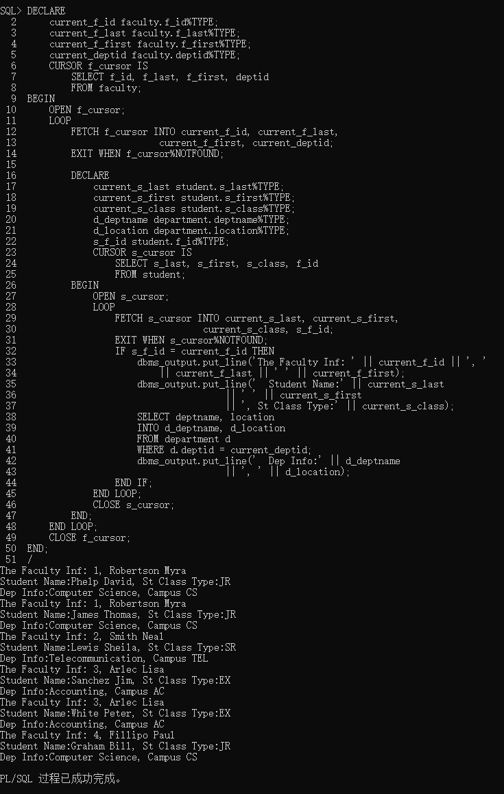

b) Using explicit cursor, edit PL/SQL program to display all departments, and its faculties.Display the output shown in Figure 5. Use **%ROWTYPE** variable to display explicit cursorvalues.

1. **DECLARE**
2. d_dept department%ROWTYPE;
3. **CURSOR** cur_dept **is** **SELECT** * **FROM** department;
4. f_facu faculty%ROWTYPE;
5. **CURSOR** cur_facu **is** **SELECT** * **FROM** faculty;
6. i **INTEGER**;
7. **BEGIN**
8. **OPEN** cur_dept;
9. dbms_output.put_line('The List of Departments and its Faculties:');
10. LOOP
11. **FETCH** cur_dept **into** d_dept;
12. EXIT **WHEN** cur_dept%NOTFOUND;
13. dbms_output.put_line('Dep ID:' || d_dept.deptid
14. || ', Dep Name: ' || d_dept.deptname
15. || ', Dep Loc: ' || d_dept.location);
16. **OPEN** cur_facu;
17. i := 1;
18. LOOP
19. **FETCH** cur_facu **into** f_facu;
20. EXIT **WHEN** cur_facu%NOTFOUND;
21. IF f_facu.deptid = d_dept.deptid **THEN**
22. dbms_output.put_line(i || ')       '
23. || f_facu.f_last || ' ' || f_facu.f_first
24. || ', who''s SOCIAL INS is ' || f_facu.soc_ins);
25. i := i + 1;
26. **END** IF;
27. **END** LOOP;
28. **CLOSE** cur_facu;
29. IF i>1 **THEN**
30. dbms_output.put_line('');
31. **ELSE**
32. dbms_output.put_line('-----No Faculty Assigned for this Department so far--');
33. **END** IF;
34. **END** LOOP;
35. **CLOSE** cur_dept;
36. **END**;

